What’s the Relationship?

Unit 1 - Lab 5

Directions: Follow along with the slides and answer the questions in **red** font in your journal.

# I have data, now what?

* Load the cdc data set and run the following code in RStudio:

View(cdc)

* **Using only the output of the code, write down something you think is interesting about the data.**
* **How interesting do you think your observation is? Would anybody else find it interesting if you told them?**

# Finding patterns in data.

* To discover (*really*) interesting observations or relationships in data, we need to find them!
  + Which is difficult if we only look at the data itself.
* The best tool for finding patterns is often ... your own eyes.
  + Plots are an excellent way to help your eye search for patterns.

# What do you observe?

* Start by looking at a plot you've seen before:

histogram(~height, data = cdc)

* **How many variables did you need to make this plot?**
* **What sorts of observations can you make about the height of our data's high schoolers?**

# What do you observe now?

* Using what you learned in *lab 1.4*, create this plot **BUT** stack one graph on top of the other.

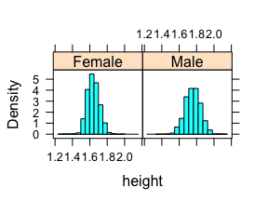

# What do you observe now?



* **How many variables did you need to make your plot?**
* **In your plot, what do you notice about the heights of *males* and *females*?**
* **Compare your plot to the one above. Which is easier to see the difference in heights?**

# Multiple variable plots

* The plot you just made is an example of a *multiple variable plot*
* Often shorten this to *multivariate plot*
* Variable 1: *height*
* Variable 2: *gender*
* Multivariate plots are tools for finding *relationships* between data.
* Let's make some new multiple variable plots you haven't created before!

# Scatter plots

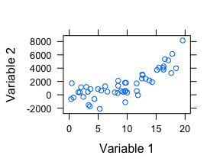

# Scatter plots

* Useful for viewing how one *numerical* variable relates to another *numerical* variable.
* Before we begin:
* **How do you think *height* and *weight* are related?**

# Creating scatter plots

* To create scatter plots, use the following function: **
* xyplot (y ~ x, data = ____ )
* **
* Use the *height* and *weight* variables to create this plot: 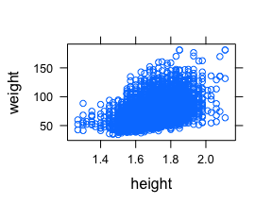

# Answer the questions based on your plot

* **As people grow taller, what happens to their *weight*?**
* **Pick a single *height*, does weight vary a lot or a little? Why do you think that is?**
* **Does the weight of shorter people vary less, more, or the same amount as taller people?**
* **What happens if you swap the *height* and *weight* variables in your code? Does the relationship between the variables change?**

# More complex scatter plots

* What happens to your plot if you run this code:

xyplot(weight ~ height | gender, data = cdc)

* **How is this code different than the one you ran previously?**
* **Do you think the relationship between *heights* and *weights* for *males* and *females* are more similar or different?**
* **How many variables did you need to create this plot?**

# Adding some color

* In the previous plot, we looked at how different gender's *heights* and *weights* varied seperately.
* What if we wanted to overlay (combine) them?
* Run the following code:

xyplot(weight ~ height, data = cdc, groups = gender)

* **How is this graph different than the previous graph? What changed in the code to make it different?**

# Mosaic Plots

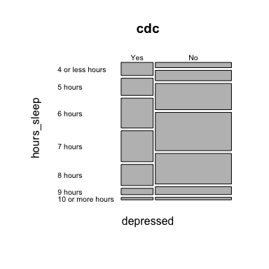

# Mosaic Plots

* Scatter plots are helpful for finding relationships between two *numeric* variables.
* Mosaic plots are helpful for finding relationships between two *categorical* variables.
* We use the following function to create them: **
* mosaicplot (y ~ x, data = ____, las = 1)
* NOTE:** We include las=1 to ensure our labels are readable.

# Create the following:

* Use the variables *depressed* and *hours_sleep* to create this mosaic plot: 

# Playing with labels

mosaicplot(depressed~hours_sleep, data=cdc, las=1)

* **What happens to the labels if you set las = 0? Or las = 2?**
* **What happens if you don't include las = 1 at all?**

# Interpreting mosaic plots

* To interpret mosaic plots, we need to look for differences in the width and height of the boxes.
* For the mosaic plot you've created:
* The width of the boxes is the **percentage** of students who said they have or have not felt depressed.
* The height of the boxes is the **percentage** of students who said they sleep however many hours.
* The width/height of the *entire* plot represents 100 percent of the students.

# Interpreting mosaic plots

* Compare the width of the *Yes* and *No* stack for the *depressed* variable:
* **Have more high schoolers reported feeling depressed or not depressed?**
* Now look at the heights of the boxes in the *yes* stack:
* **For high schoolers who have reported feeling depressed, which are the two most common amounts of sleep?**

# Interpreting mosaic plots

* Look at the heights of the boxes in the *no* stack:
* **For high schoolers who not have reported feeling depressed, which are the two most common amounts of sleep?**
* Finally, look at the people who reported sleeping *4 or less hours*:
* **How does the percentage of students who reported feeling depressed and sleeping 4 or fewer hours compare to the students who did not report feeling depressed and sleeping 4 or fewer hours?**